**ASSIGNMENT IN DAY 1**

**PRATIKSHA TAMBE (243072)**

1. To list all records with sal > 2000 and comm>200

**Select * from emp where sal > 2000 and comm > 200;**



1. To list all record with job=’Clerk’ or sal>2000

**Select * from emp where job = ‘clerk’ or sal>2000;**

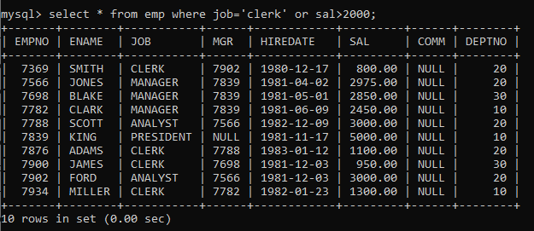

1. To list all the record with sal=1250 or 1100 or 2850

**Select * from emp where sal in(1250,1100,2850);**

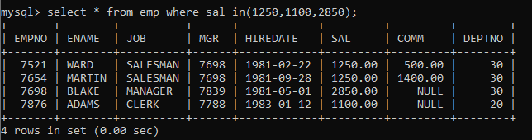

1. To list all employees with sal>1250 and <2850

**Select * from emp where sal between 1250 and 2849;**

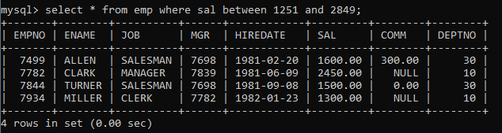

1. To list all employees with name ends with AS

**Select * from emp where ename like ‘%AS’;**



1. To list all employees with job starts with C and ends with K

**Select * from emp where ename like ‘C%K’;**

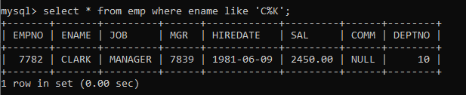

1. To list all employees with job contains L at third position and M at third last position

**Select * from emp where ename like ‘—L%’ and ‘%M—‘;**



1. To list all the record with sal not equal to 1250 or 1100 or 2850

**Select * from emp where sal not in(1250,1100,2850);**

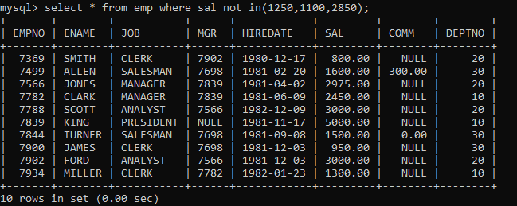

1. To list all employees with sal not >1250 and <2850

**Select * from emp where sal not between 1250 and 2850;**

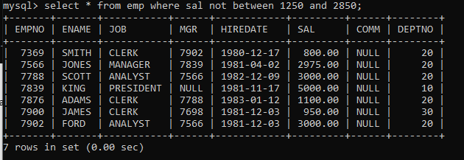

1. To list all employees with job starts with C , E at 3rd position and ends with K

**Select * from emp where ename like ‘C%’ and ‘—E%’ and ‘%K’;**



1. To list all rows with comm is null

**Select * from emp where comm is null;**

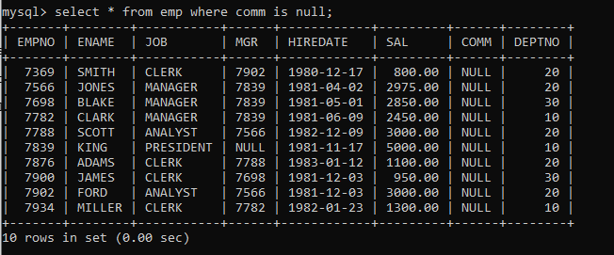

1. To list all employees with sal is null and name starts with ‘S’

**Select ename, sal from emp where sal is null and ename like ‘S%’;**



1. To list all employees with job contains 5 characters

**Select * from emp where LENGTH(job)=5;**

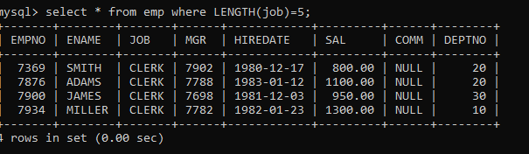

1. To list all employees with name contain ‘A’ at 1 position and job contains 5 characters

**Select * from emp where ename like ‘A%’ and LENGTH(job)=5;**

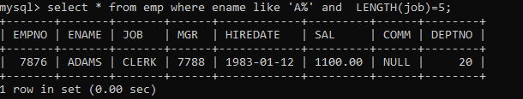

Q2. Solve the following

1. Retrieve the details (Name, Salary and dept no) of the emp who are working in department code 20, 30 and 40.

**Select ename, sal, deptno from emp where deptno in(20,30,40);**

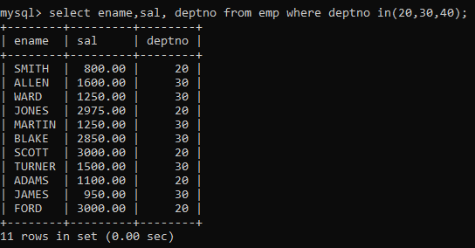

1. Display the total salary of all employees . Total salary will be calculated as sal+comm+sal*0.10

**Select ename, comm, sal, sal+ifnull(comm,0)+sal*0.10 NetSalary from emp;**

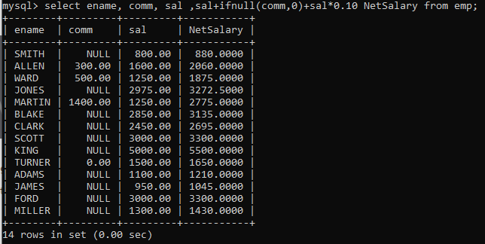

1. List the Name and job of the emp who have joined before 1 jan 1986 and whose salary range is between 1200and 2500. Display the columns with user defined Column headers.

**Select ename “Employee Name” , job, hiredate “Hired Date”, sal “Salary”**

**From emp**

**Where hiredate<’1986-01-01’ and sal between 1200 and 2500;**

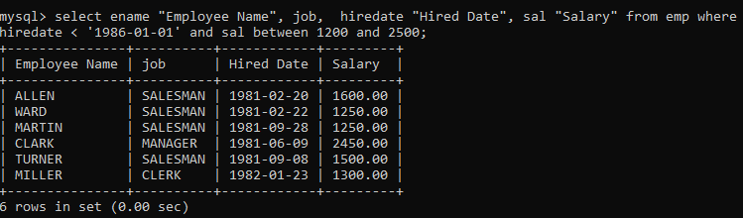

1. List the empno, name, and department number of the emp works under manager

with id 7698

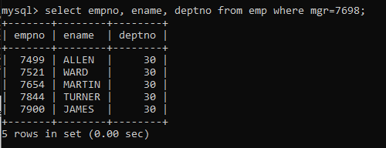

1. List the name, job, and salary of the emp who are working in departments 10 and 30.

**Select ename, job , sal, deptno from emp where deptno in(10,30);**

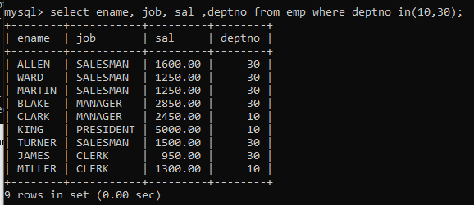

1. Display name concatenated with dept code separated by comma and space. Name the column as ‘Emp info’.

**Select ename, deptno, concat(ename,’, ‘,deptno) Emp_info from emp;**

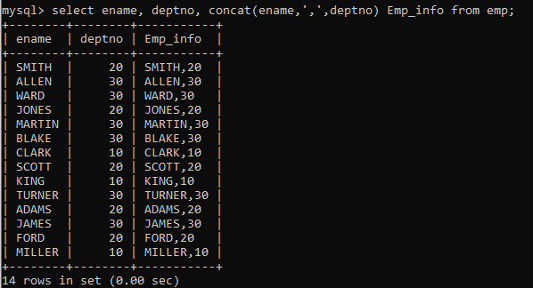

1. Display the emp details who do not have manager.

**Select * from emp where mgr is null;**

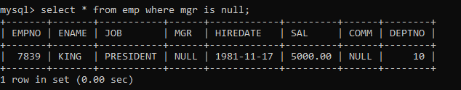

1. Write a query which will display name, department no and date of joining of all employee who were joined January 1, 1981 and March 31, 1983. Sort it based on date of joining (ascending).

**Select ename, deptno, hiredate**

**From emp**

**Where hiredate between ‘1981-10-01’ and ‘1983-03-31’**

**Order by hiredate;**

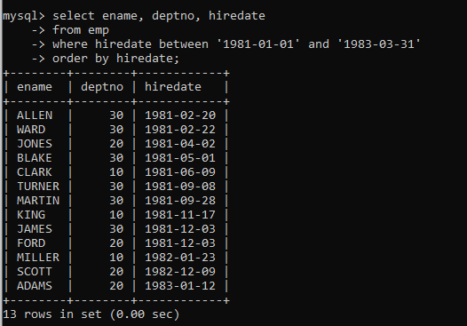

1. Display the employee details where the job contains word ‘AGE’ anywhere in the Job

**Select job from emp**

**Where job like ‘%AGE%’;**

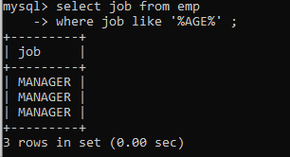

1. List the details of the employee , whose names start with ‘A’ and end with ‘S’ or whose names contains N as the second or third character, and ending with either ‘N’ or ‘S’.

**Select * from emp**

**Where ename regexp ‘^A.*S$|^.N.*|^..N.*[NS]$’;**

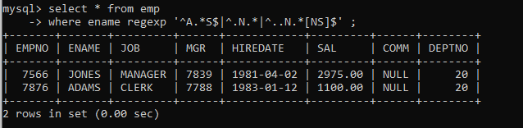

1. List the names of the emp having ‘_’ character in their name

**Select ename from emp**

**Where ename like ‘%\_%’;**

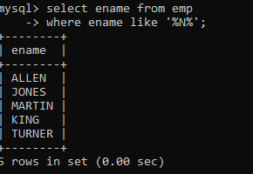

**Group functions**

1. Display the Highest, Lowest, Total & Average salary of all employee. Label the columns Maximum, Minimum, Total and Average respectively for each Department. Also round the result to the nearest whole number.

**Select ceil(max(sal)) Maximum, ceil(min(sal)) Minimum, ceil(sum(sal)) Total , ceil( avg(sal)) Average from emp;**

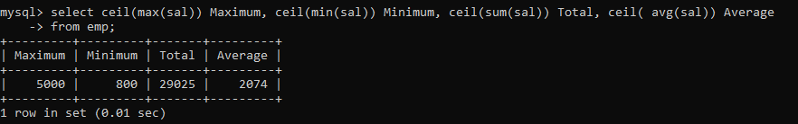

1. Display Department no and number of managers working in that department. Label the column as ‘Total Number of Managers’ for each department.

**select deptno,job, count(*) "Total Number of Managers"**

**from emp**

**where job="MANAGER"**

**group by deptno, job;**

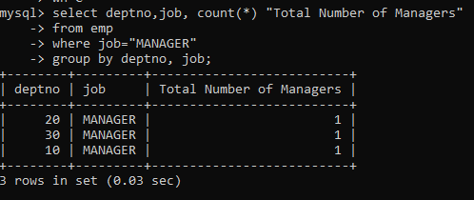

1. Get the Department number, and sum of Salary of all non managers where the sum is greater than 20000

**Single Row functions**

1. To list all employees and their email, to generate email use 2 to 5 characters from ename Concat it with 2 to 4 characters in job and then concat it with ‘@mycompany.com’

**select concat(left(ename, 4), left(job, 4), ’@mycompany.com’) from emp;**

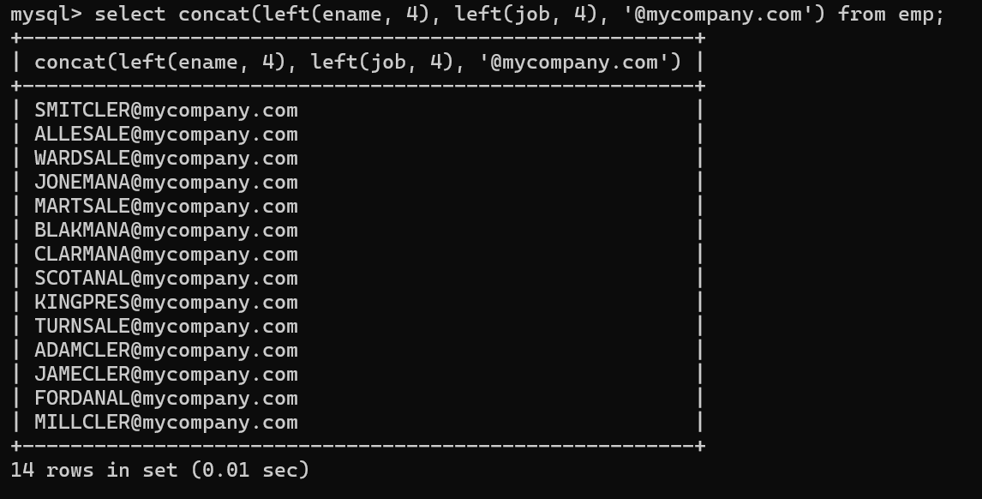

1. List all employees who joined in September.

**select hiredate, empno from emp**

**-> where month(hiredate)=9;**

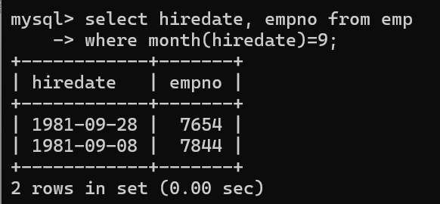

1. List the empno, name, and department number of the emp who have experience of 18 or more years and sort them based on their experience.

**select empno, ename, deptno,floor(datediff(curdate(),hiredate)/365) "Experience" from emp**

**-> where floor(datediff(curdate(),hiredate)/365)>41**

**-> order by hiredate;**

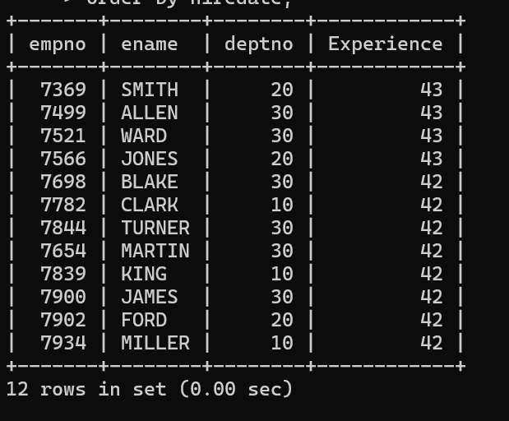

1. Display the employee details who joined on 3rd of any month or any year

**select * from emp**

**-> where day(hiredate)=3;**

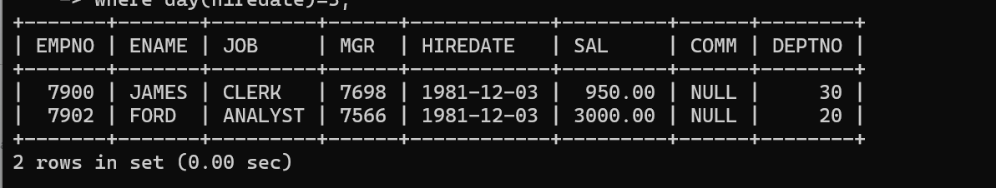

1. display all employees who joined between years 1981 to 1983.

**select * from emp**

**-> where year(hiredate) between 1981 and 1983;**

